**PROJECT DOCUMENTATION**

|  |  |  |
| --- | --- | --- |
| **TEAM MEMBERS** | **EMPLOYEE ID** | **Email** |
| K. Mohan Kumar | MO20085039 | mohankumar.krishnamoorthy@wipro.com |
| M. Praveen kumar | PR20085120 | praveen.m63@gmail.com |
| Srinivasan R | SR20084838 | srinivasan.rathinam@wipro.com |
| Rakhsanth R | RA20085208 | rakhsanth.r86@wipro.com |
| K. Ranjith Kumar | RA20084906 | ranjithkumar.karuppusamy@wipro.com |
| Arun Kumar A | AR20084706 | arunkumar.asaimani@wipro.com |

**Landing Page:**

This is the page where the user/Admin lands in the first place. Once they sign in with their credentials they are redirected to their respective homepages.

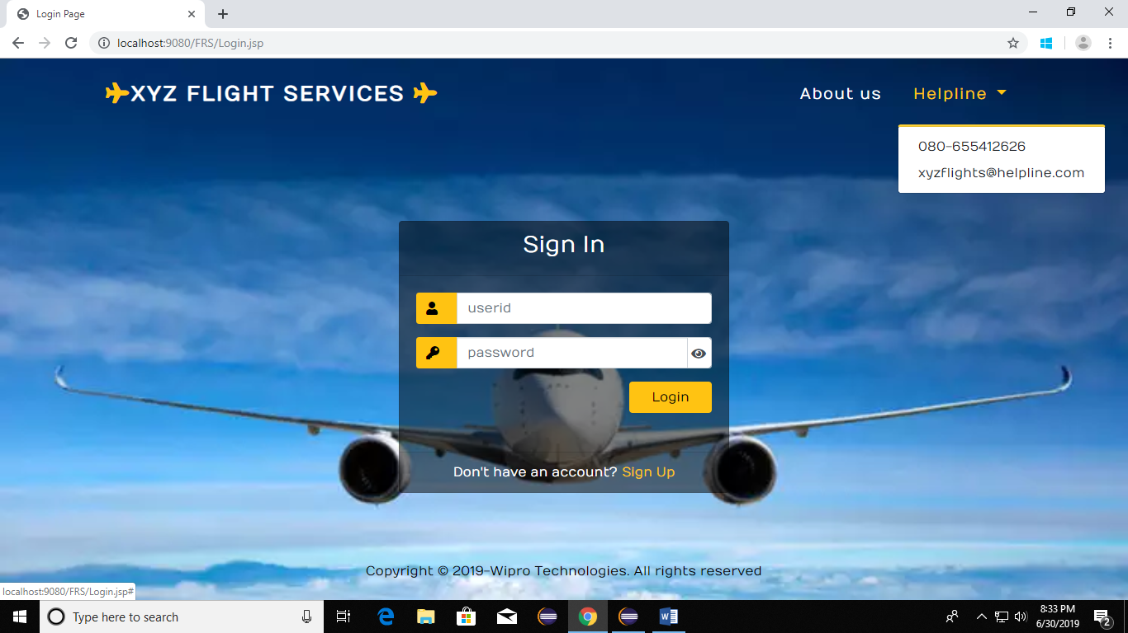

The database table used for this is as below.

|  |  |
| --- | --- |
| **Field Name** | **Data Type** |
| User ID | Varchar(6) |
| Password | Varchar(16) |

**Admin Homepage:**

This is the page where the admin is redirected afer signing in. First he can view the flight details. Based on the requirement he can edit or delete the flight deteails/ flights.

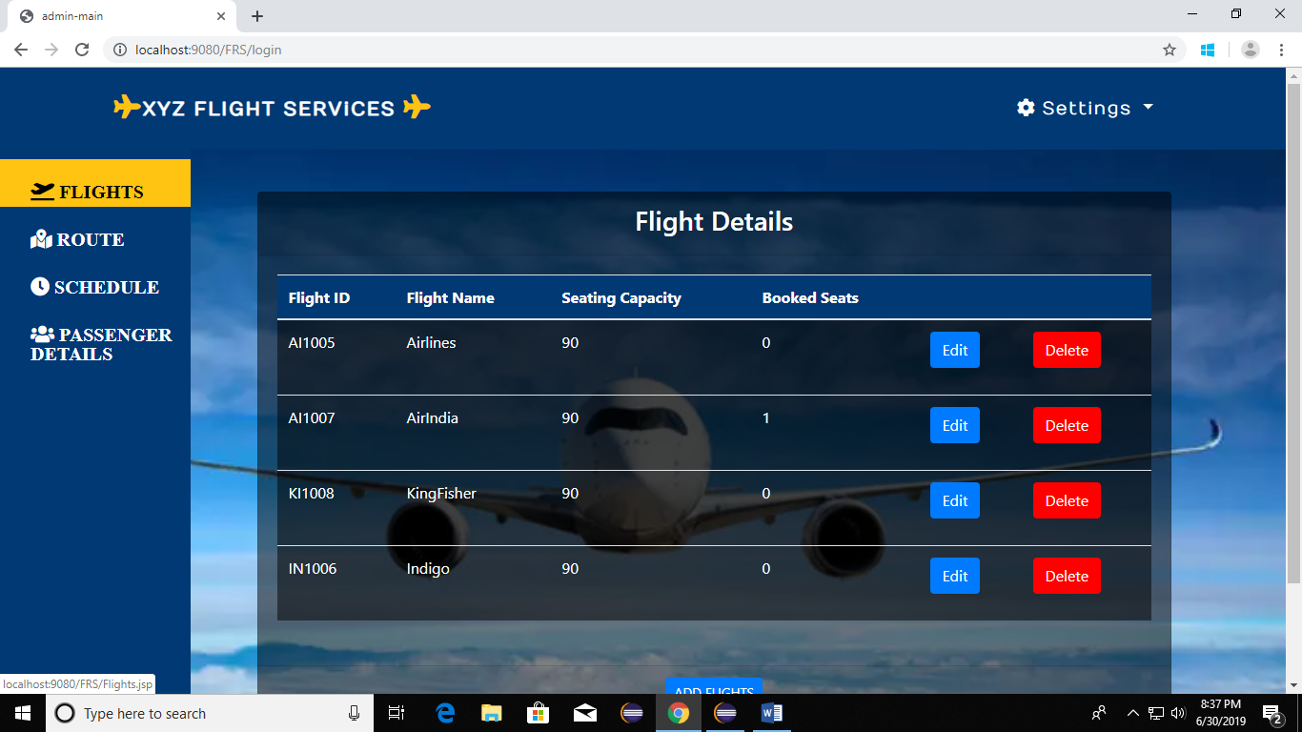

He can also add new flights according to the schedule and route.

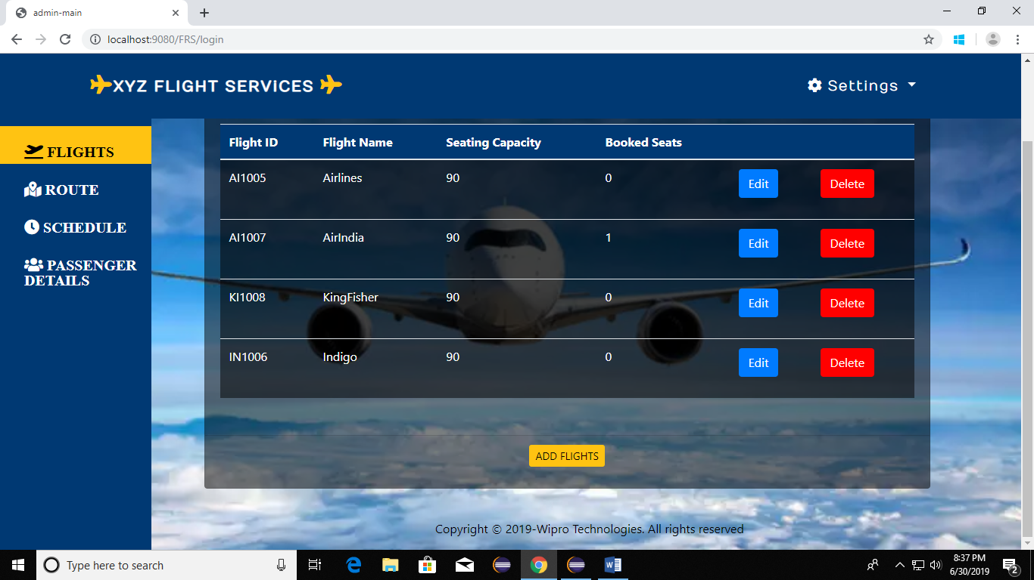

This the page where he can add a new flight.

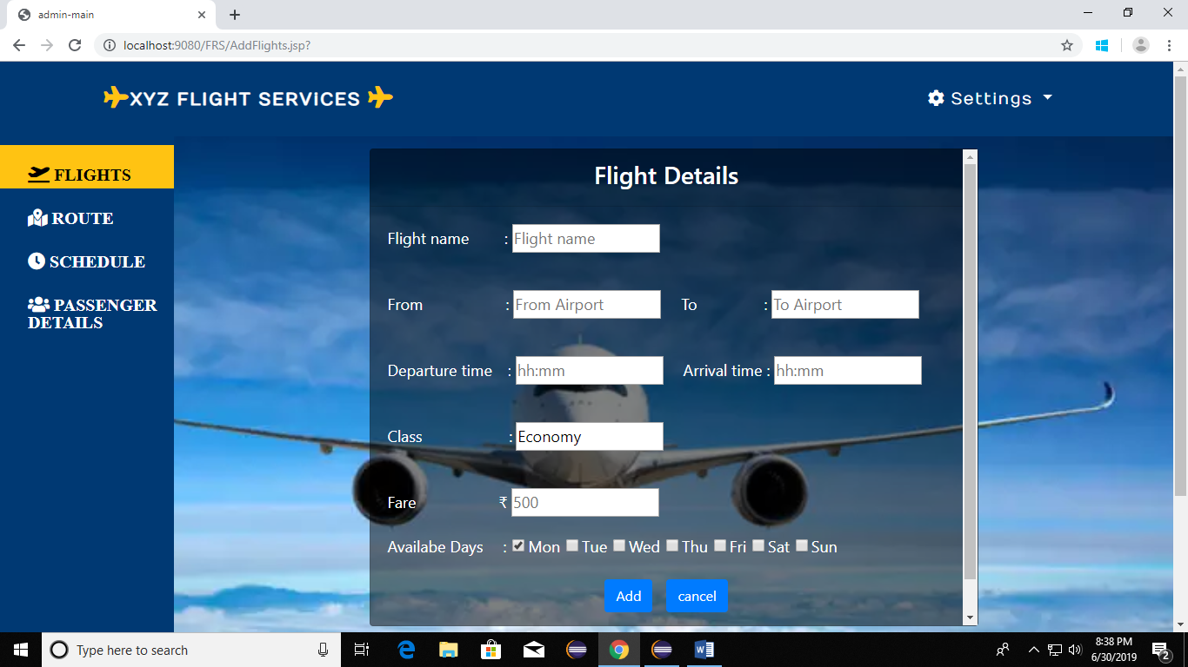

The database table used for this details is as below:

|  |  |
| --- | --- |
| **Field Name** | **Data Type** |
| Flight Name | Varchar(50) |
| From | Varchar(50) |
| To | Varchar(30) |
| Departure time | Varchar(5) |
| Arrival time | Varchar(5) |
| Business class | Int |
| Economy class | Int |
| First class | Int |
| Booked seats | Int |
| Available days | Varchar(30) |
| Flight ID | Varchar(6) |

**Admin Route Editing Page:**

This is the page where the admin can edit the flight routes if there is any change after adding the flights.

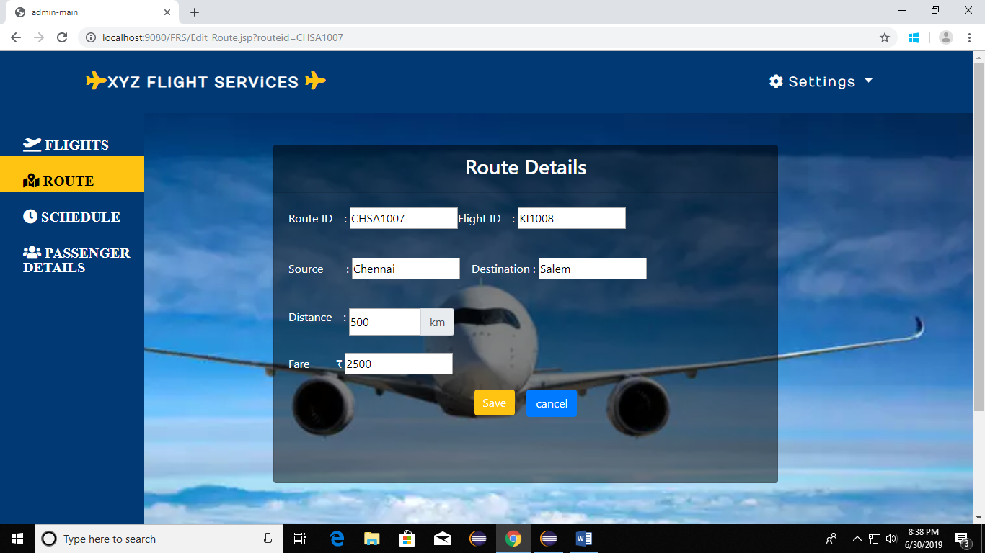

The databse table used for the route details is:

|  |  |
| --- | --- |
| Fields | Data Type |
| Flight ID | Varchar(6) |
| Route ID | Varchar(8) |
| Source | Varchar(20) |
| Destination | Varchar(20) |
| Distance | Number |
| Fare | Number |

**Admin Schedule Editing Page:**

In this page the admin can edit the flight schedule details if they need to be changed after adding the flight details.

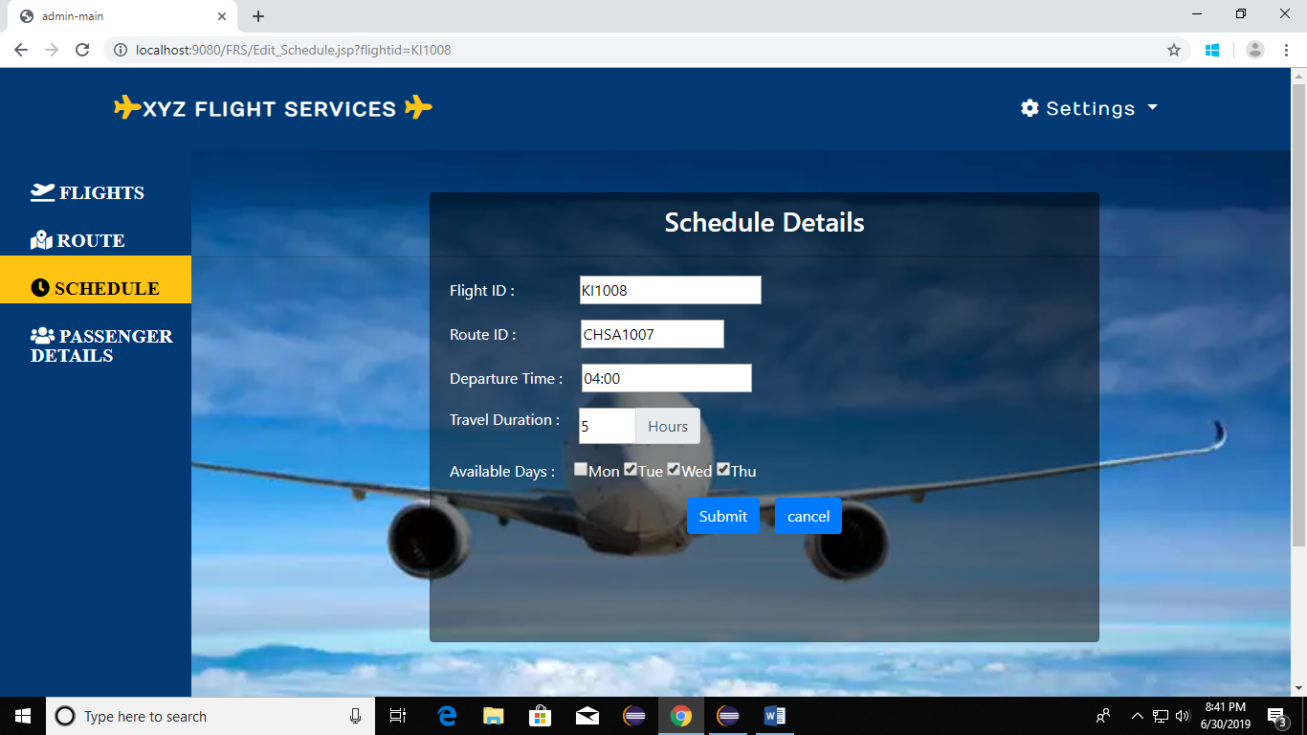

The database table used for storing these data is:

|  |  |
| --- | --- |
| Fields | Data Type |
| Flight ID | Varchar(6) |
| Route ID | Varchar(8) |
| Travel Duration | Varchar(30) |
| Available Days | Int |
| Departure time | Varchar(5) |
| Arrival time | Varchar(5) |

**Admin Passenger Details Viewing Page:**

In this page the admin can view the booked passenger details.

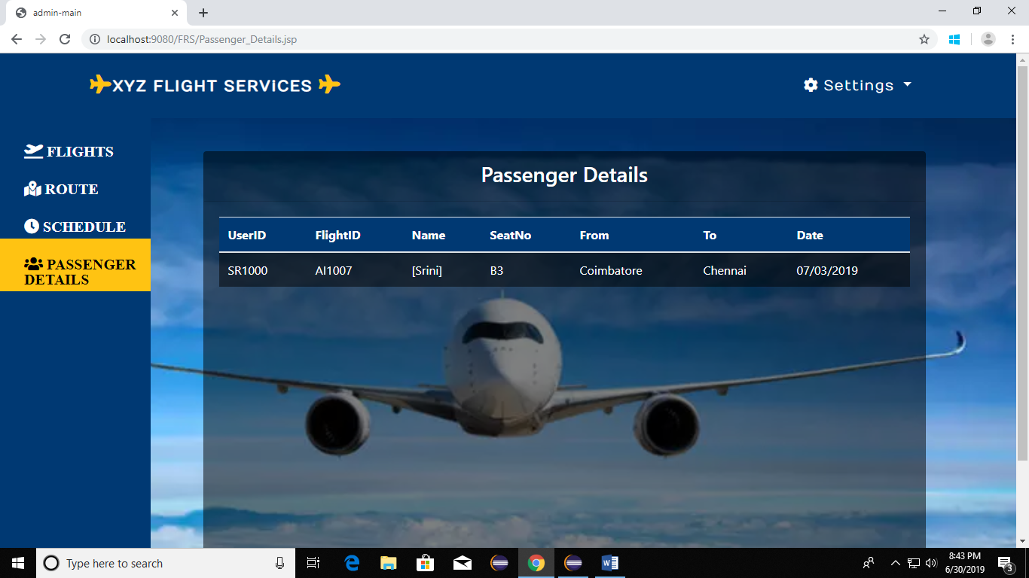

The database table used for displaying and storing these details is:

|  |  |
| --- | --- |
| **Fields** | **Data Type** |
| User ID | Varchar(6) |
| Flight ID | Varchar(6) |
| Seat no | Varchar(20) |
| Name | Varchar(100) |
| From | Varchar(30) |
| To | Varchar(30) |
| Date Of Journey | Varchar(10) |

**Admin’s Page To Change Password:**

Here provision is given for the admin to change his password.

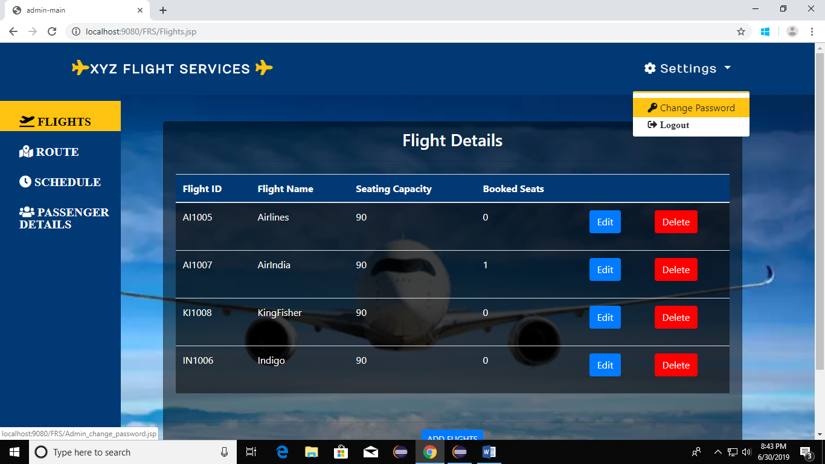

Afetr clicking the change password option in the settings dropdown the below page appear’s for allowing him to change his password.

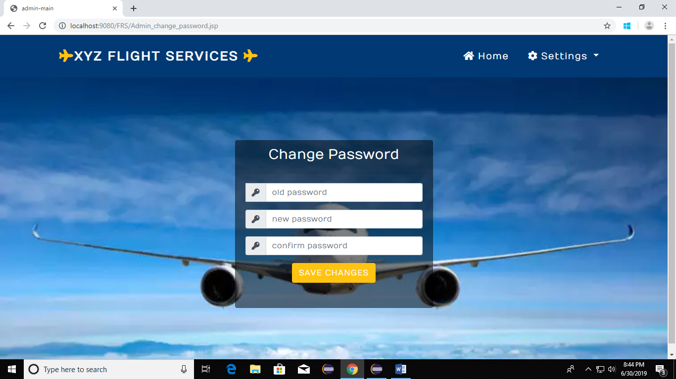

The database table used consists of userID password which is given in the admin login part.

**Admin Logout:**

The admin can logout using the logout dropdown option in the settings menu.

The database table gets updated and the login/logout status is also updated.

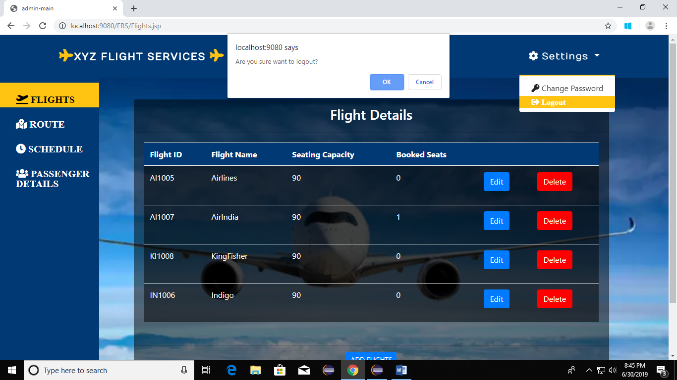

**User Sign Up Page:**

This is the user sign up page where new users can sign up. After sign up they can sign in using the landing page which is explained in the 1st page. The database table used for this is same as for sign in pages.

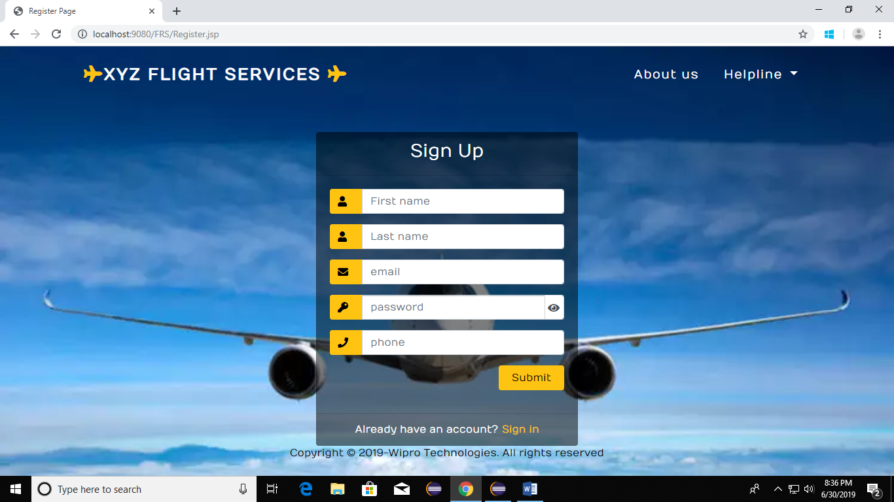

**Validation for password entering.**

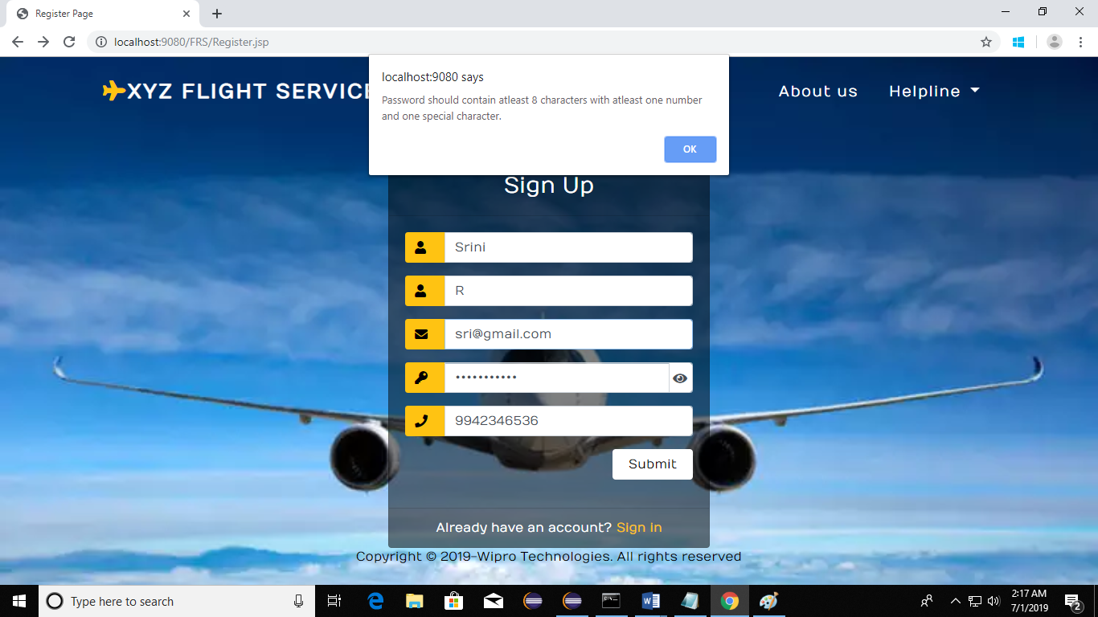

**Validation for existing user.**

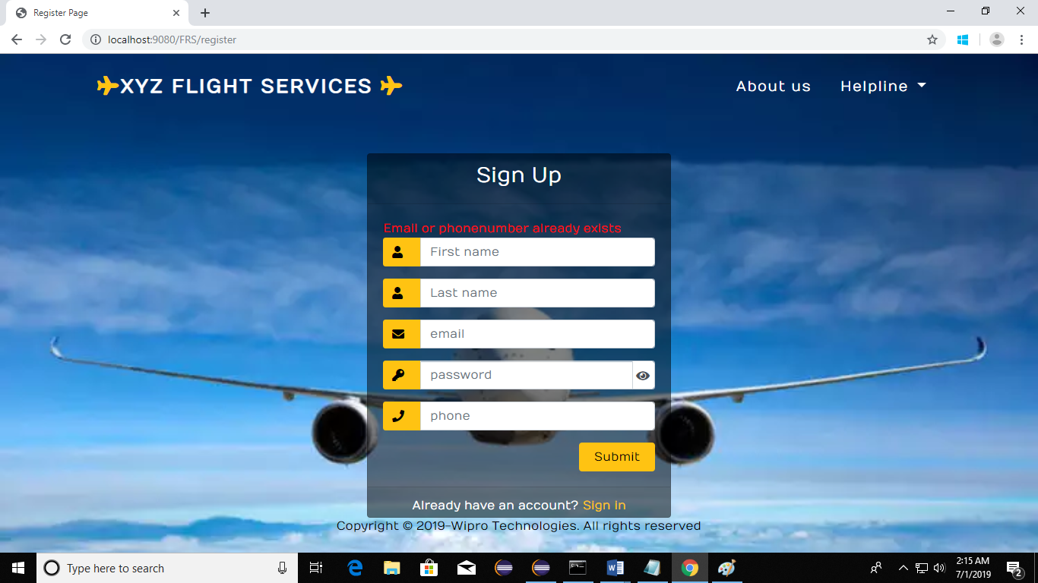

**User Home Page:**

This is the user home page, here they can enter and search flights based on their requirements.

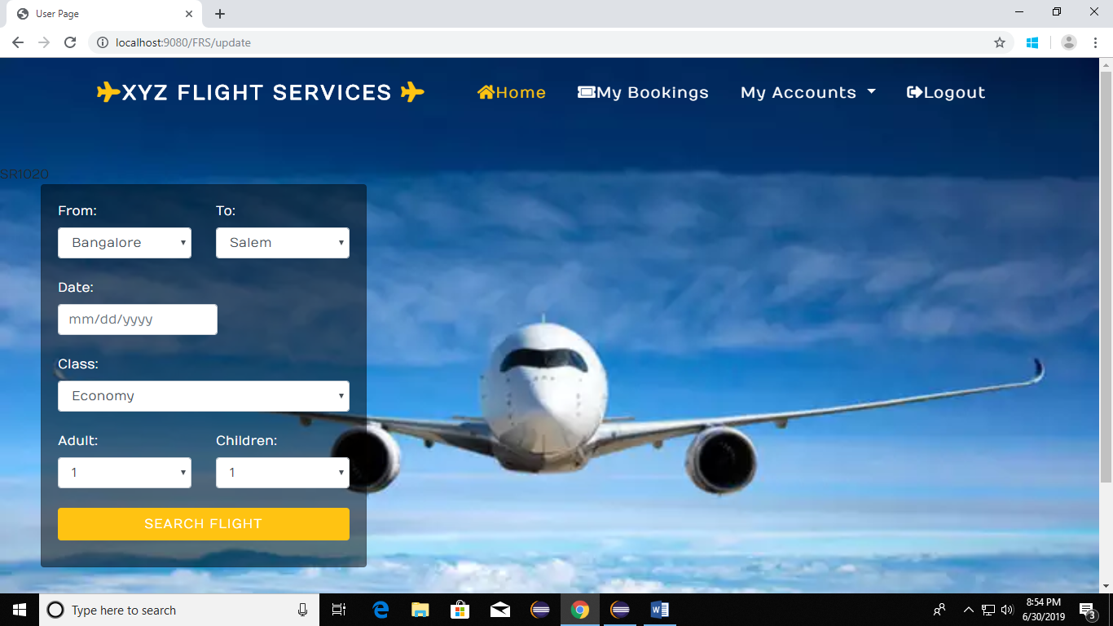

The database table used for this above details is:

|  |  |
| --- | --- |
| **Field Name** | **Data Type** |
| Flight Name | Varchar(50) |
| From | Varchar(50) |
| To | Varchar(30) |
| Departure time | Varchar(5) |
| Arrival time | Varchar(5) |
| Business class | Int |
| Economy class | Int |
| First class | Int |
| Booked seats | Int |
| Available days | Varchar(30) |
| Flight ID | Varchar(6) |

**Flight Bookings :**

Once the user searches, flights matching their requirements show up automatically and they can book any one of the shown flights.

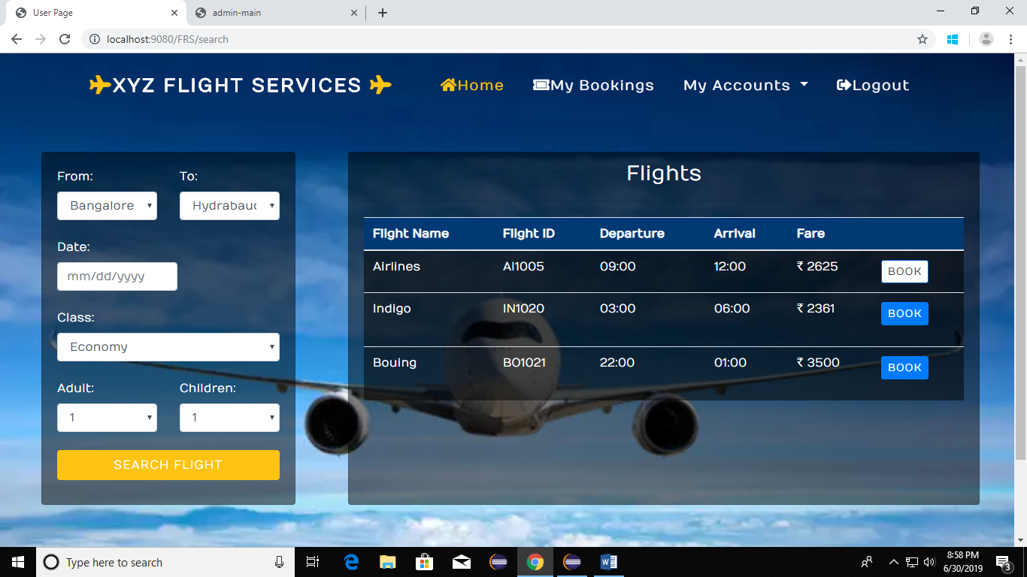

Once they click the book button, the next page shown below asls for the seats and passenger details with address to book their ticket.

After the enter all the redquired credentials and click on the submit button, the ticket will get booked.

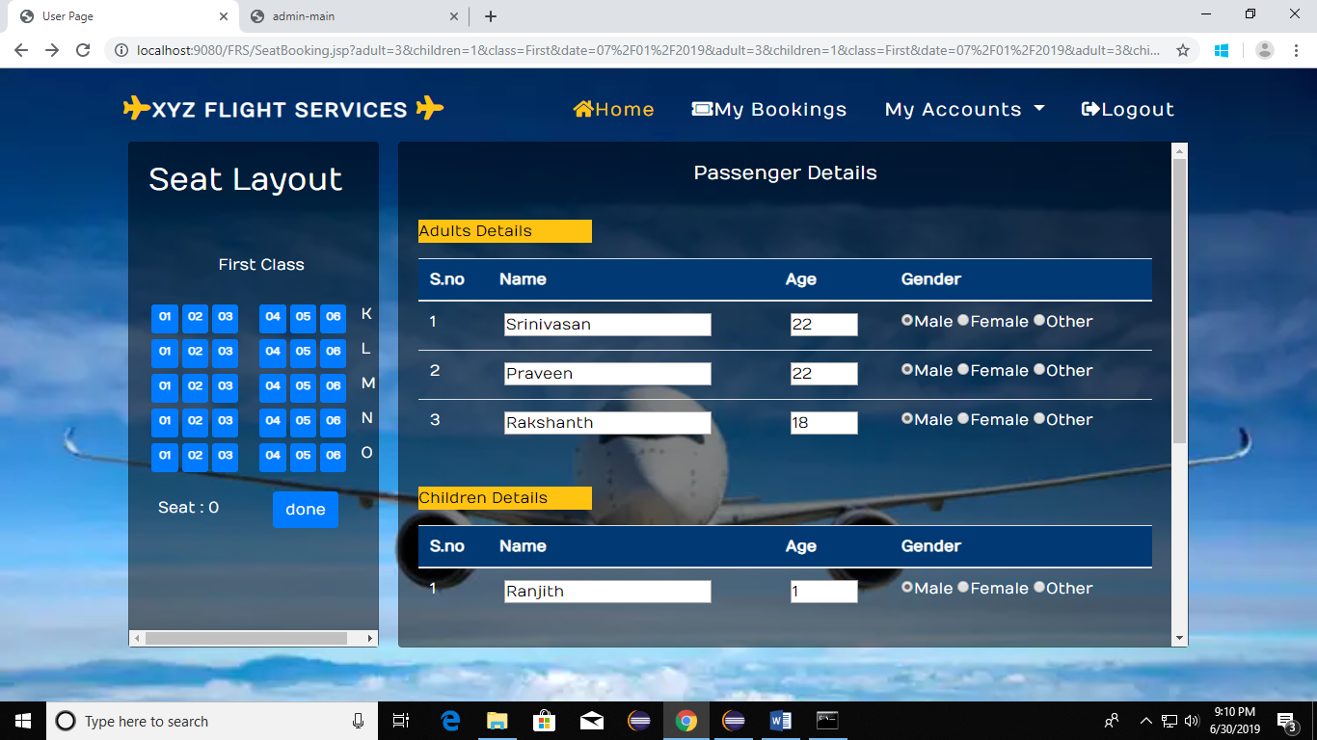

Seat selecting and passenger details entering phase.

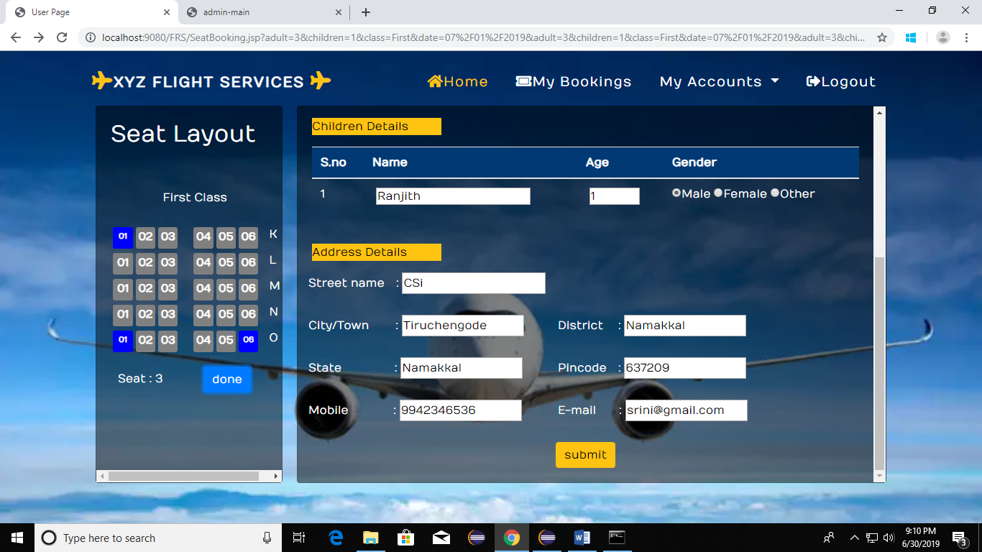

Already booked seats are shown as already blocked seats.

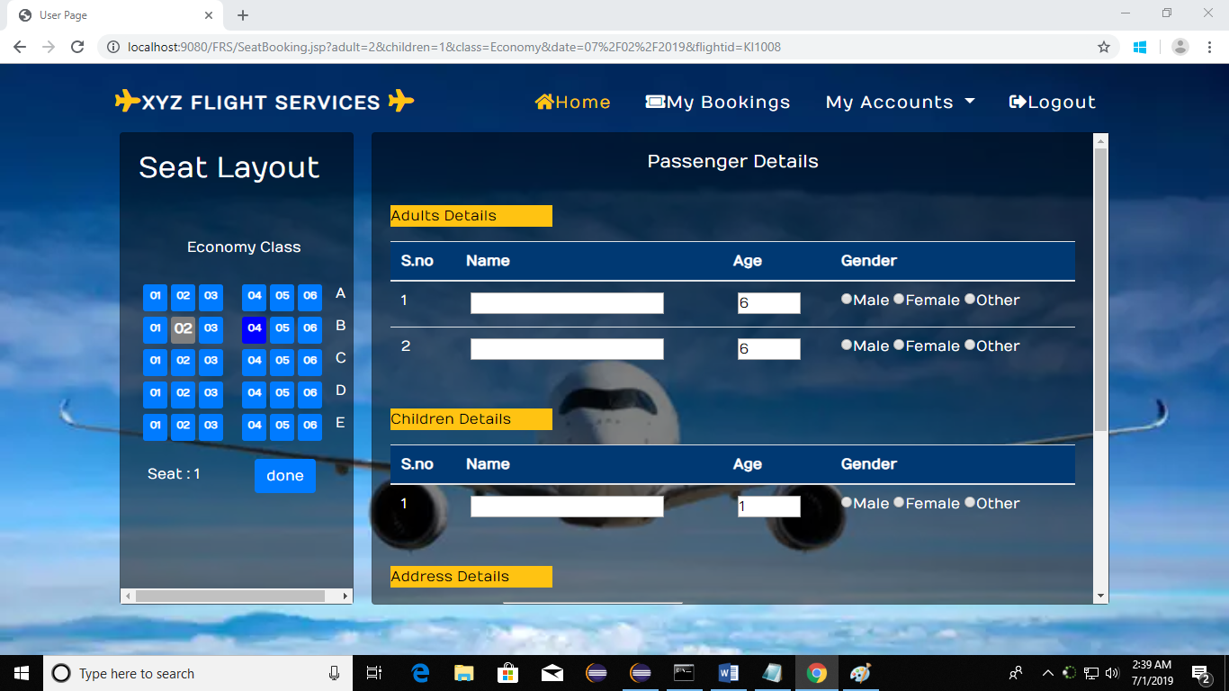

**User Ticket Cancellation:**

In this page the user can view his booked ticket details and if they want to cancel the ticket they can cancel by just clicking on the cancel button.

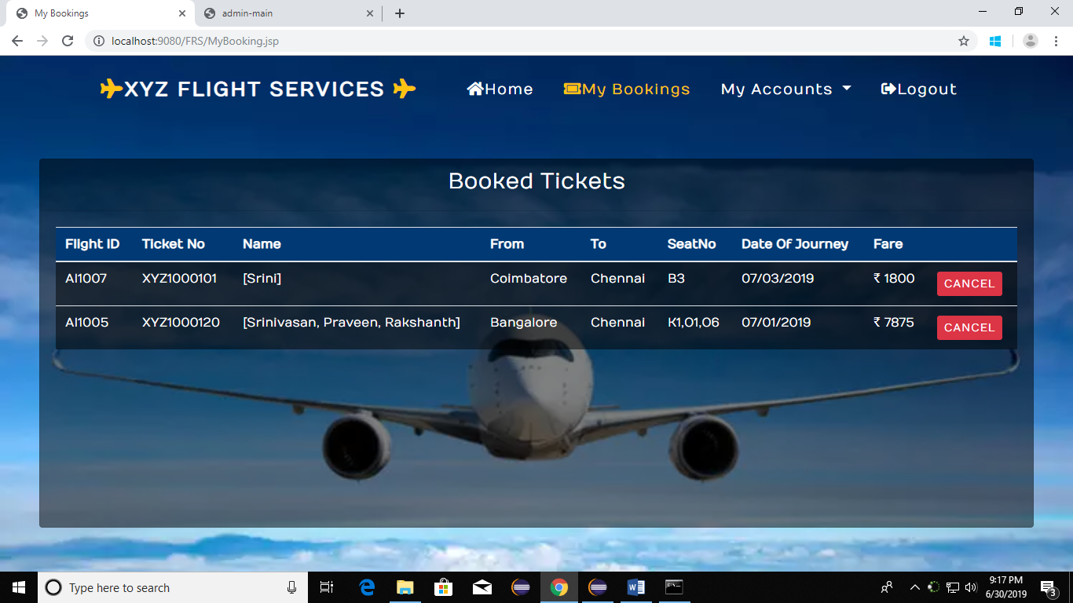

**User Profile Editing Page:**

In this page the user can select to edit his profile or change password also as shown below.

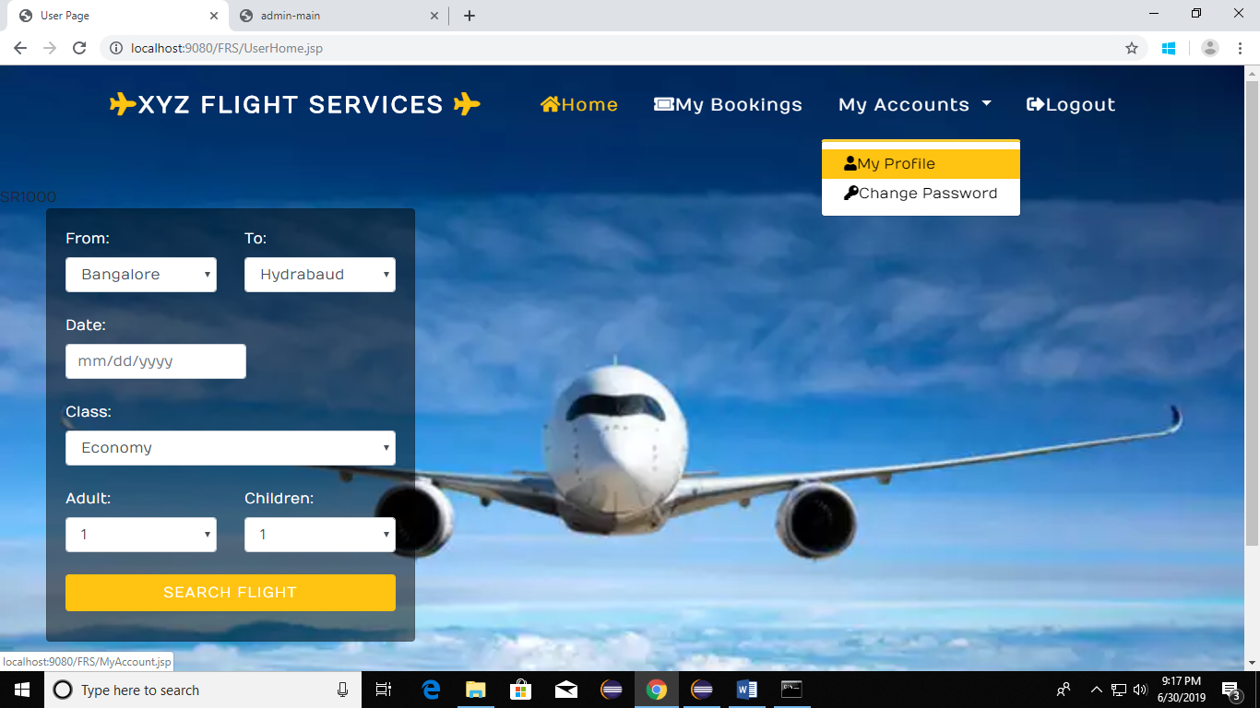

**User Profile Editing:**

Once the user chooses to edit their profile they can edit in the below page.

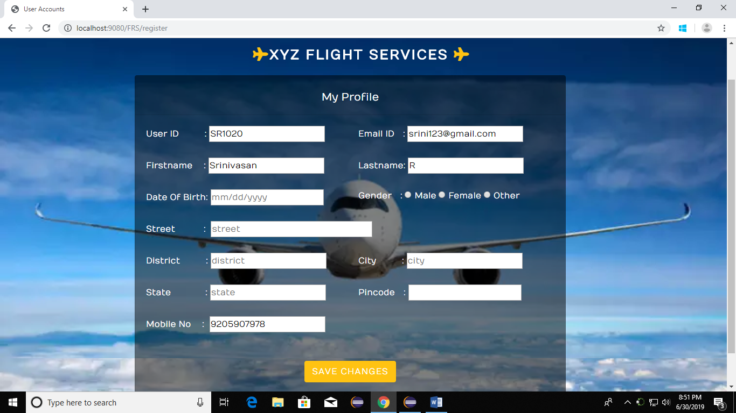

Th edatabase table used for these details is:

|  |  |
| --- | --- |
| Fields | Data Type |
| Firstname | Varchar(50) |
| Lastname | Varchar(50) |
| Username | Varchar(100) |
| Email | Varchar(70) |
| Password | Varchar(16) |
| Phone Number | Varchar(10) |
| Id | int |
| Used Id | Varchar(6) |
| Date Of Birth | Varchar(10) |
| Gender | Varchar(7) |
| Street | Varchar(20) |
| Location | Varchar(20) |
| City | Varchar(20) |
| State | Varchar(20) |
| District | Varchar(20) |
| Pincode | Varchar(6) |

**Change Password For User :**

In the accounts tab if the user clicks change password dropdown, he can change in the page as shown below.

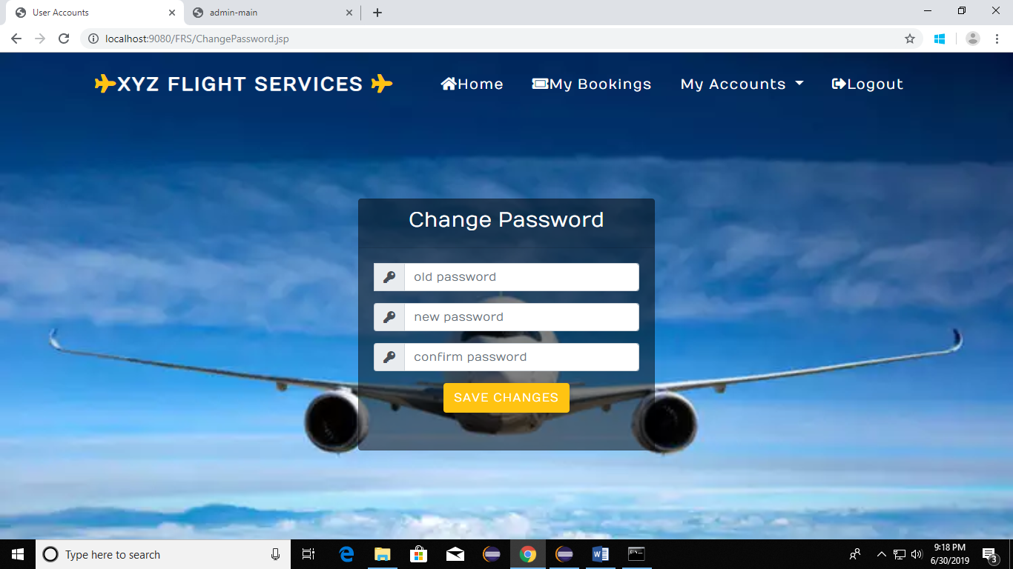

**Password change validation:**

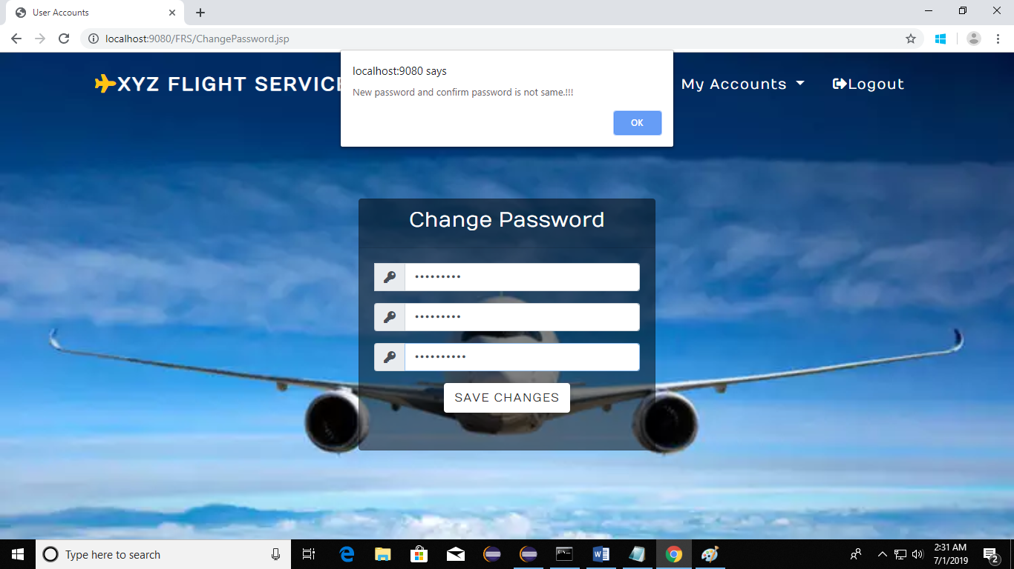

**User Logout :**

